Policy | Reviewed | By whom?
Missing Young Person Protocol | 25/11/2025 | Victoria Bacon / Daisy Upson

Next review date | 25/11/2026
DSL | Victoria Bacon
Contact details | Victoria@pushforward.uk
 | 0330 8180186
 | www.pushforward.uk

Please see process detailed on Page 2

Notes:
- If the safeguarding chat is not available, use the WhatsApp back up chat, if that is not available keep a log of everything you are doing and when you do have service make contact to H/O by whatever means.

- If you are out in public and need help – remember your ID badges have an emergency message on the back you can pass to someone to help you.

- Not every situation is the same, you may have to deviate for safety reasons from a particular section – ensure however whatever action you take it is done so with safety in mind and that you log your actions and keep HQ updated.

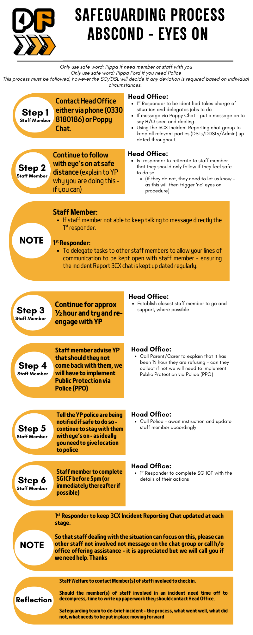 | 