Table of Contents
Introduction. 2
Push Forward Quality Assurance Team 2
Internal Quality Assurance Strategy 2
IQA Cycle 3
Carrying out Internal Quality Assurance 4
Risk Assessment 4
Observing Assessor practice 4
Talking to learners 5
Sampling assessed learners work and assessment records 5
Arranging Team meetings 6
Example Agenda 6
Arranging standardisation activities 7
In summary 8

Introduction
Internal Quality Assurance is integral to Push Forward and is in place to ensure that the qualifications are being delivered in line with accreditation / awarding bodies requirements. Below is the role of the Internal Quality Assurer (IQA):
- to carry out and evaluate internal assessment and quality assurance systems.
- to support assessors/tutors.
- monitor the quality of tutor / assessor performance.
- meet external quality assurance requirements.
Push Forward IQA Team
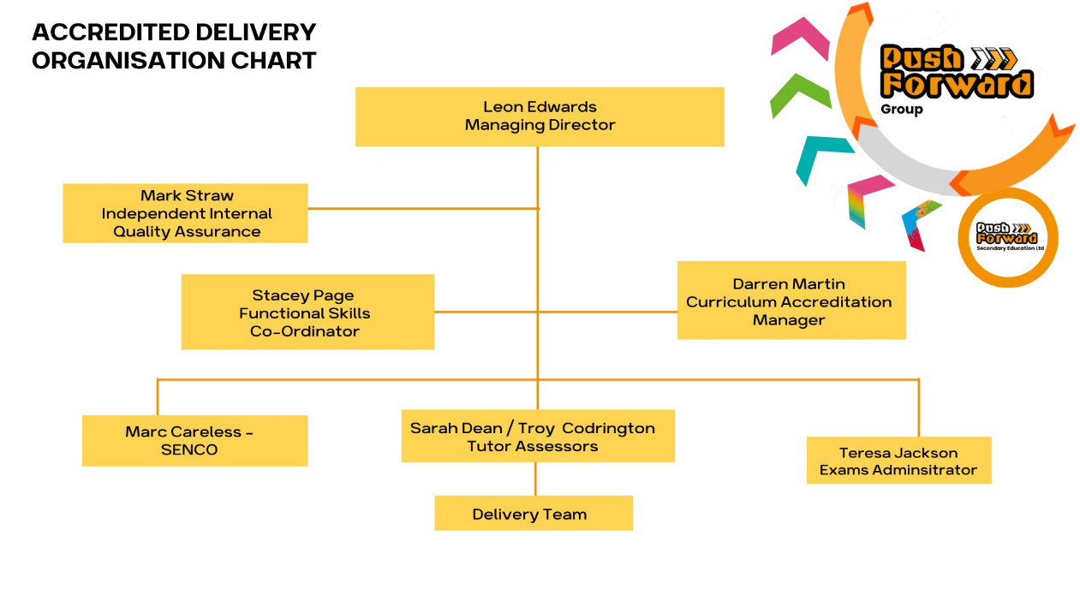Internal Quality Assurance Plan
This Internal Quality Assurance guidance will set our plans and implementation process across Push Forward.. It gives an overview of what the IQA procedures will be for Push Forward.
- how the IQA will verify assessment practices.
- how the IQA will develop and support assessors.
- how the IQA will monitor delivery of programmes.
The IQA and accreditation team will set up an Internal Quality Assurance file that has all necessary information regarding the assessors that they support and to store all the completed paperwork ready for the EQA.

Our Internal Quality Assurance file will include the following:
- Record of assessor induction
- Pre verification of assessment plans of tutors
- Observation of assessment form
- Dip sampling record form
- Sampling record form
- CV’s, certificates and specimen signatures for all tutors/assessors.
- Evidence of recorded CPD for all tutors/assessors.
- Evidence of Internal Quality Assurance that has taken place.
- Previous EQA reports.
- Evidence of meetings/training/standardisation.
- Evidence of any reasonable adjustments that have taken place.
- Evidence of additional support that has taken place.
- Progress reports.
- Learner engagements / participation
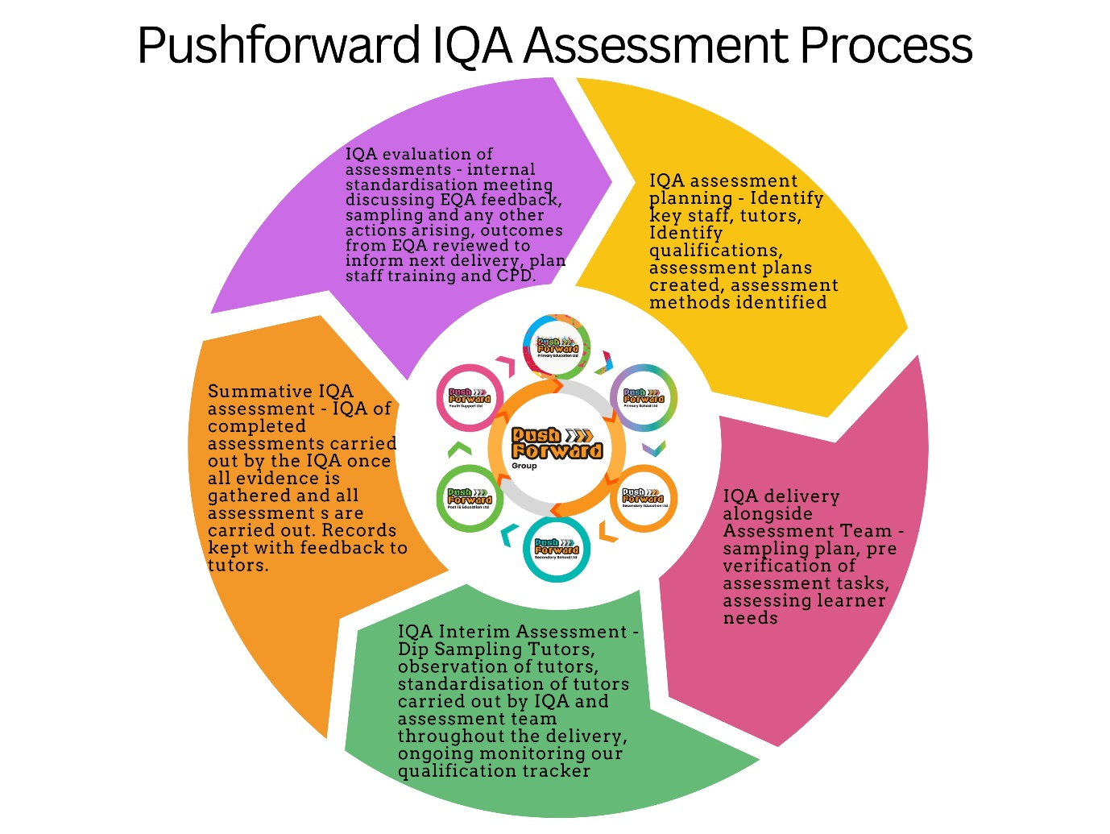

Carrying out Internal Quality Assurance
Push Forward’s Internal Quality Assurance adopts a holistic and differential approach to assessment rejecting the “one size fits all approach”. Our IQA’s responsibility is to decide how to apportion time to meet the needs of the learners and tutors/assessors. We will plan to regularly monitor the activities that our assessors carry out, along with the decisions they make. As part of this process, we will observe tutors and dip sample learner work. This is to ensure we are performing our job roles correctly and not disadvantaging our learners in any way. The rationale can be recorded within our standardisation meetings.
Activities that PF IQA plan to carry out include:
- Observing assessor practice.
- Talking to learners.
- Dip sampling work
- Sampling assessed learners' work and assessment records.
- Arranging team meetings.
- Arranging standardisation activities.
- Ensuring young people are equipped at the right level to achieve the qualification – it is expected that all learners will do a learning styles initial assessment so that the tutors can meet their unique learning needs
We will always keep records of any activity that is carried out for quality assurance purposes. When completing any records, attention needs to be given to ensure signatures are provided to verify and authenticate the work. We will be completing documents electronically, an electronic signature should be obtained.
Risk Assessment
As an organisation new to qualifications, we must be robust and vigilant to manage our risk and put mitigation in place to minimise risk, we need to be aware of tutors with minimal experience of delivering accredited outcomes, the levels of support each tutor needs. Robust action planning is necessary along with clear feedback to manage our risk thresholds. We will also have the qualification tracker that has ongoing monitoring and feedback to tutors.

Observing assessor practice - qualification
A good way of ensuring our assessors are performing adequately is to see them in action. Not only will this give us the opportunity to see them making assessment decisions, but we will also be able to talk to learners afterwards. Documenting our observations will help to ensure us to remain objective when making decisions regarding assessor's competence. When arranging to carry out an observation, we will need to make sure the learner is aware that we are not observing them but their assessor. PF will put them at ease and explain that the role of the IQA is there to help and support, not to be critical of them, support and challenge. We need to ensure our tutors / assessor(s) are performing their job role correctly and making valid and reliable assessment decisions. We also need to check that the area is safe and that any resources used are appropriate.
Talking to learners
After observing the assessor, it is an ideal time to talk to the learner and gain feedback regarding the assessment process (a checklist will be used for this purpose). We will always give the learner the opportunity to ask any questions and to discuss any aspects of the assessment and IQA. At PF the consent of young people is essential as we are a rights-based organisation. Our feedback to tutor / assessor(s) will always be delivered in a safe and timely manner away from the learner. If for any reason the tutor / assessor has any other commitments at the time, a quick verbal account will be given and then a date and time arranged for more formal feedback. It could be that we identify some areas for development, in which case we will discuss this sensitively with the tutor/ assessor and reach an agreement on how to proceed. This will be followed up and any action points that are needed to feature on an action plan with clear support outlined to ensure the targets and can be met.
Sampling assessed learner’s work and assessment records
An excellent way of monitoring assessor practice and decisions is to sample the learners’ work they have assessed, along with the assessment records.
Ideally our sampling of learner’s work will be ongoing, we will use Dip sampling as our sampling plan throughout the accreditation and identify dates through the accreditation journey to keep abreast of tutors and learner’s work via the qualification tracker. We will ensure all qualification / tutors are covered through our Dip sample process. If a problem is identified at the formative stage, there is a likelihood that changes can be made to put it right. Summative sampling can check that the full assessment process has been completed successfully and that all documents are complete. These dates will be included in our qualification tracker and awarding bodies sampling plan.

The benefits of interim / Dip sampling are that it gives opportunities to monitor:
- all assessment types and methods, whether they are safe, valid, fair and reliable.
- consistency of decisions between assessors.
- consistency of assessor interpretation of what is being assessed.
- good practice that can be shared between assessors.
- how assessors are completing their paperwork, evidence of learner’s work
- how effective assessment planning is.
- What effective feedback to learners looks like.
- how effective the scheme of work is
- how learners are progressing and what has been achieved.
- if assessors need any support or further training.
- if learners need any support or have any requirements.
- if there are any problems that need addressing before the learner completes.
- the views of others, for example learners, employers and witnesses.
The benefits of summative sampling are that it gives opportunities to check:
- all documents are fully completed.
- all requirements have been met enabling certificates to be claimed
- assessors have implemented any action points.
- the assessment decisions are correct.
- the learner evidence is VARCOSTI (Valid, Authentic, Relevant, Current, Objective, Sufficient, Transparent, Inclusive)
- there are adequate assessment plans and feedback records.
Arranging team / standardisation meetings
Team / Standardisation meetings are essential to plan and reflect for all tutors / assessors and those involved in the accreditation journey. We aim to plan the dates a year in advance, so that this will ensure everyone knows when they will take place and therefore will be able to attend. Initially we will be holding meetings every 6 weeks. An agenda should be formulated to ensure all important aspects of the assessment and IQA process are covered. The agenda will be circulated in advance by e-mail. The IQA will chair the meeting, and another colleague will take notes. These will be produced after the meeting as soon as is possible, within a week and placed on share point within the identified accreditation folder.

Example Agenda
IQA and assessor team meeting Venue and time
- Present
- Apologies for absence
- Minutes of last meeting
- Matters arising
- Programme: recruitment, new starters, changes/updates to standards and qualifications
- Assessment: record keeping, methods used, current progress of learners, issues or concerns, continuing professional development activities
- Internal quality assurance - observations and sampling dates, registrations and certifications, appeals and complaints, general feedback to assessors from monitoring activities
- External quality assurance - feedback and reports, action points
- Standardisation - feedback from recent activity, planning new activities
- Sampling work
- Equality and diversity
- Health and safety
- Any other business
- Date and time of next meeting
Arranging standardisation activities
Standardisation of practice ensures the assessment and IQA requirements are interpreted accurately, and that everyone is making comparable, fair and consistent decisions.
Aspects that can be standardised include:
- assessment activities - looking at safety and fairness, validity and reliability, deciding on alternative methods for learner requirements or needs.
- creating a bank of assessment materials, i.e. worksheets, indicative content.
- how assessors interpret the standards and assessment requirements and how they reach their decisions.
- how learner evidence meets the requirements.
- the way assessment plans, and feedback records are completed.
- the way feedback is given to tutors and learners.
- the way learner reviews are carried out.
- updating assessment and IQA documentation, i.e. checklists, qualification trackers, worksheets and records.
Within the team meeting assessors will be asked to bring along a learner's evidence for a unit or aspect they have assessed, with their supporting assessment records.
These can be swapped between assessors who can then reassess them. The activity will be anonymous as learner and assessor names will be removed beforehand. A discussion can then take place to see if all assessors are interpreting the assessment requirements in the same way and are making the same decisions. This is also a chance to see how different assessors complete the records and the amount of detail they write. This activity can lead to an action plan for further training and development of assessor practice.
Assessment types and methods should also be standardised. If one assessor has produced a project or an assignment for their learners to carry out, they should share it with the other assessors. We will ensure all learners have access to the same assessment materials. It is also our chance to make sure that all questions / assessment methods are pitched at the right level for our learners.
In summary
The IQA’s main role is to ensure that ALL aspects of the qualification are quality assured. The accreditation journey, not only being planned, but actually taking place and by following the above steps above we should be able to achieve this.
We want to ensure that all learners within Push Forward are given equal opportunity to access qualifications and through our IQA process we can guarantee that all learners will be given a consistent, accessible, detailed and transparent accreditation journey, one that is earnt along with enriching and enlarging their personal and social development.

